**Assignment 4.1**

**Problem Statement1**

Write a Java program, to take a HDFS Path as input and display all the files and sub-directories in that HDFS path.

**Program Code:**

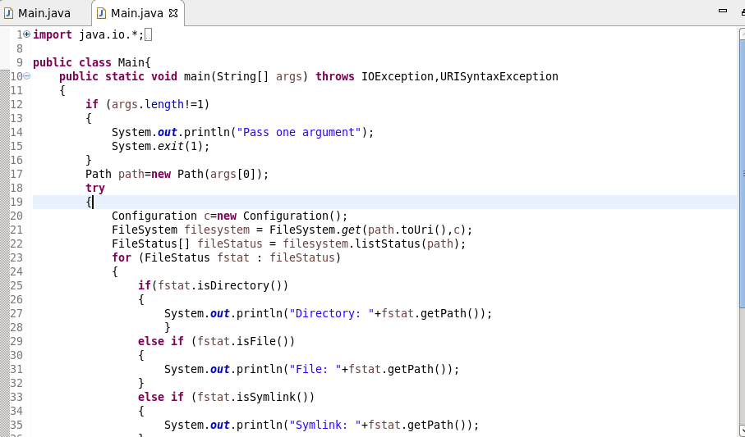

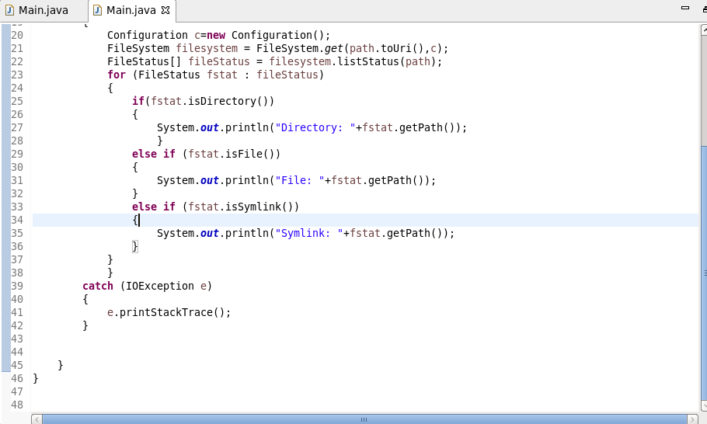

**Program Output:**

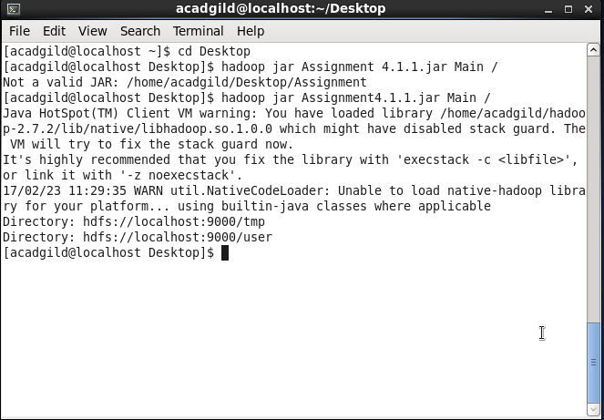

**Problem Statement2**

Modify the previous program to list all the files and sub-directories in the HDFS path recursively.

**Program Code:**

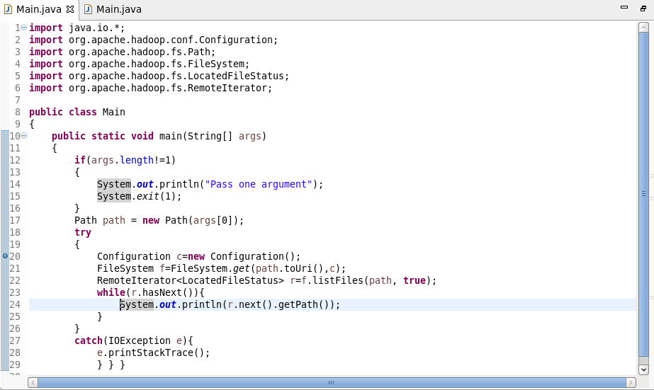

**Program Output:**

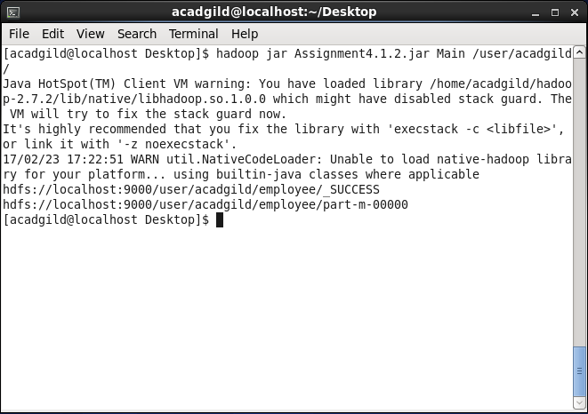

**Problem Statement3**

Modify the previous program to take multiple HDFS paths (separated by space) and list all the files and sub-directories in those HDFS paths recursively.

**Program code:**

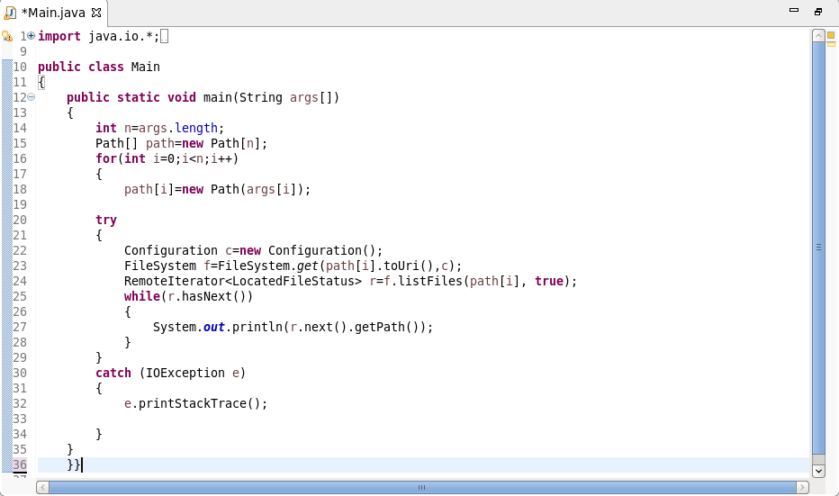

**Program output:**

